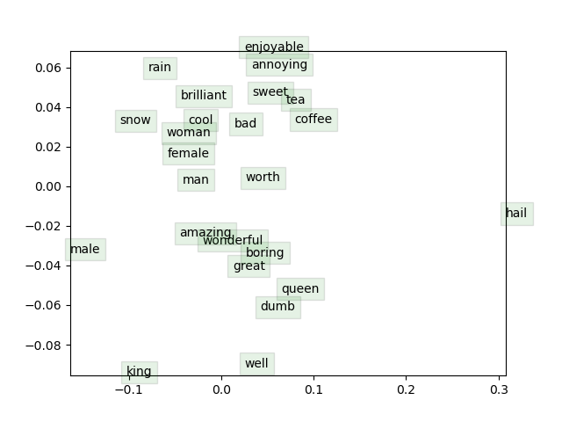

Part 2c:

Some prominent clusters include the “goodness” adjective cluster at the center of the plot (amazing, wonderful, boring, great, dumb), the other adjective cluster near the top of the plot (enjoyable, annoying, brilliant, cool, bad), drinks (tea, coffee), and gender terms (woman, female, man). I expected weather terms (rain, snow, hail) to cluster together and one adjective cluster instead of two. Also, some analogy relations (female : queen :: male : king) seem to hold, while others do not (woman : man :: female : male).